Documentation of Hammer Boomerang Market Place

1. **The Sql Queries you need to test your Database**

**a. Show All Hammer Results**

SELECT * FROM hammer ORDER BY seeking ASC;

**b. Show all User Results**

SELECT * FROM user ORDER by id ASC;

**c. Show all offer which is create by user correspond to hammers**

SELECT o.*,h.*,u.* FROM offer as o INNER JOIN hammer as h ON o.hammer_id=h.id INNER JOIN user as u ON u.id=o.user_id ORDER BY o.submitted DESC;

**d. Show all message sent by users to each other**

SELECT m.*,from_user.email as from_email_id,from_user.username as from_username,to_user.email as to_email,to_user.username as to_username FROM message as m INNER JOIN user as from_user ON from_user.id=m.from_user_id INNER JOIN user as to_user ON to_user.id=m.to_user_id ORDER BY m.sent DESC;

**e. Show their Recent hammer which is viewed by Users**

SELECT r.*,h.*,u.* FROM recentlyview as r INNER JOIN hammer as h ON h.id=r.hammer_id INNER JOIN user as u ON u.id=r.user_id ORDER BY r.created_dt DESC

**2. List of parts of the assignment you have completed or not completed.**

|  |  |  |  |
| --- | --- | --- | --- |
| **Sri** | **Feature** | **Criteria** | **Status** |
| 1 | Initial Data | Requirements satisfied | Done |
| 2 | Creating Database | Table structure, data types, field lengths, initial data entry | Done |
| 3 | User accounts | Account sign-up | Done |
| 4 | User accounts | Validation that password meets complexity requirements (at least 5 characters) | Done |
| 5 | User accounts | Log in and Log out | Done |
| 6 | Viewing items | List of all items | Done |
| 7 | Viewing items | Unavailable and accepted offers indicated | Done |
| 8 | Making offers | Users can make an offer on an item | Done |
| 9 | Making offers | Offers only on available item | Done |
| 10 | Making offers | Users can review offers made on their items | Done |
| 11 | Messages | Send a message to a user’s | Done |
| 12 | Messages | List messages from other users | Done |
| 13 | Aggregate data | Total items on the site | Done |
| 14 | Aggregate data | Top three most-wanted items | Done |
| 15 | Bonus optional task - Moderation | Meets specification (user report, moderator list, reputation system) (no partial marks) | Not Done |
| 16 | Documentation | Initial data and test queries | Done |

**3. Anything interesting or cool you'd like to draw your marker's attention to**

**a. ReceiveInbox.php**

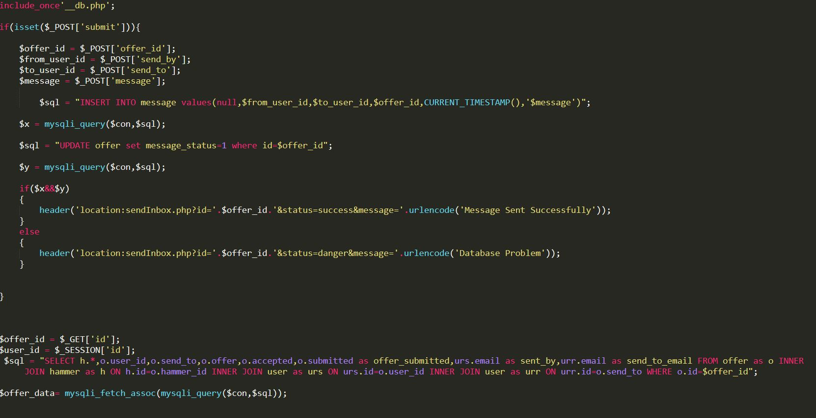

In this part, sending message concept is great. The logic which I created for send sms was very interesting for me. Using of Global variables, Session variables and Mysqli Functions makes this part interesting for me.

**b. received.php**

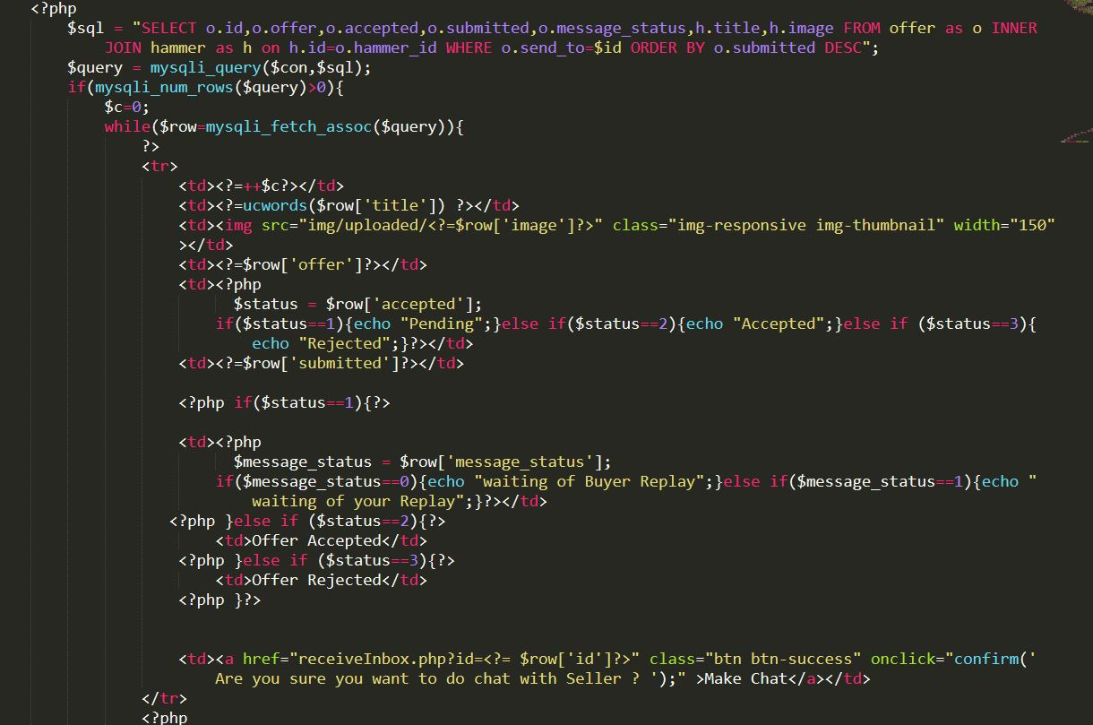

In this part, Creating Table with various conditions like offer acceptance , current status of offer so according to that my GUI(front end) of tables also changing which was very interesting code for me.